BAXTER BARN
Fall City, Washington
An Educational Coloring &
Activity Book
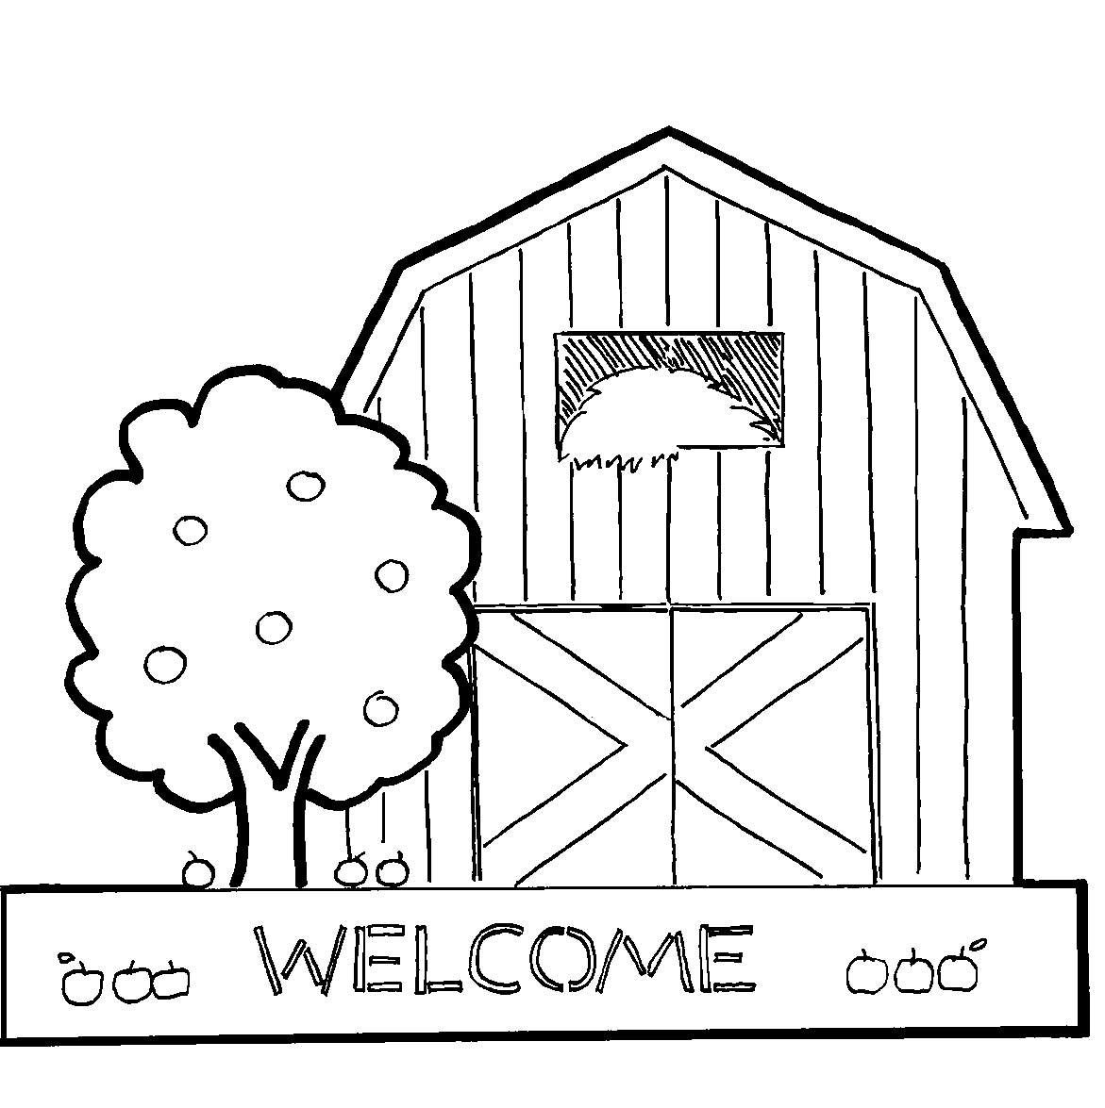

The Baxter’s came to Fall City in 1875. Over 100 years ago, they raised chickens for a living so they built a very large chicken coop. In 1955 the coop was not repairable so they took it down moved it across the road and built the Baxter Barn.

For 73 years The Grange in Issaquah has supplied the Baxter’s farming needs. The Granges’ support and first-hand knowledge of farming has been a tremendous help to us over the last two years.

